**Sports Management System (SportConnect)**

**REPORT**

# ABSTRACT

“SportConnect” is a Sports Management System which manages the activity of many Sports at a time. It also manages the selection events for students into universities. Using “SportConnect” a user complete their registration process in a quick manner compared to manual process. This system also provide the information collectively of all ongoing and upcoming sports event throughout the University.

SportConnect is a dedicated website tailored for a specific university, serving as the central hub for all sports and recreational activities on campus. Designed to foster community engagement and enhance the sports experience for students, the platform caters to four distinct user roles: students, admin, instructors, and coordinators.

Students, the primary beneficiaries of the platform, gain access to comprehensive information about ongoing and upcoming sports events. They can explore a wide range of sports and games, and based on their interests, participate in various events. Through SportConnect, students stay informed and connected to the vibrant sports culture within the university.

Admin users, representing the higher authorities such as the Heads of Departments (HODs), possess full access rights to oversee and manage all aspects of the platform. They ensure smooth operation and compliance with university policies while maintaining a bird's-eye view of user activities and event logistics.

Instructors, appointed as heads of specific events or coaches for particular sports, play a pivotal role in talent scouting and team selection. With the authority to evaluate student performance, instructors use SporConnect to identify promising athletes and assemble competitive teams.

Coordinators act as the backbone of sports events management, handling logistics, scheduling, and coordination. Their responsibilities include organizing venues, managing registrations, and facilitating communication among stakeholders. Through SportConnect, coordinators streamline event operations and foster a seamless experience for participants.

Students can check out what sports events are coming up and join in if they want. Admins are like the bosses who make sure everything runs smoothly on the site. They can see what everyone is doing and keep things in order. Instructors are like coaches who decide which students get to join certain events based on how good they are. They help pick the teams. Coordinators are like the organizers behind the scenes. They make sure events happen on time and everyone knows what's going on.

SportConnect revolutionizes the way university sports are organized and experienced, offering a digital platform that enhances connectivity, accessibility, and efficiency. By empowering students, administrators, instructors, and coordinators, Sports Connect cultivates a vibrant sports community within the university, enriching the overall campus experience.

SportConnect is a special website just for our university, where students can find out about all the sports events happening on campus. It's like a big notice board for sports! There are four types of people who use the site: students, admins, instructors, and coordinators.

SportConnect makes it easier for everyone involved in university sports – from students to admins, instructors, and coordinators – to stay connected and make the most of sports events on campus. It's like having a sports community right at your fingertips!

# Index

|  |  |  |  |
| --- | --- | --- | --- |
| **CHAPTER** |  | **TOPIC** | **Page No.** |
| Chapter 1 |  | **INTRODUCTON** |  |
|  | 1.1 | Overview | 7-8 |
|  | 1.2 | Problem Statement | 8 |
|  | 1.3 | Objective of Project | 8-9 |
|  | 1.4 | Applications or Scope | 9-10 |
|  | 1.5 | Organization of Report | 10-11 |
| Chapter 2 |  | **LITERATURE SURVEY** |  |
|  | 2,1 | Problem Statement | 12 |
|  | 2.2 | User Interviews | 12 |
|  | 2.3 | Existing Platforms | 12-13 |
| Chapter 3 |  | **PROPOSED METHEDOLOGY** |  |
|  | 3.1 | Background | 14 |
|  | 3.2 | Project platforms used in project | 15 |
|  | 3.3 | Proposed Methodology | 15-16 |
|  | 3.4 | Project Modules | 16-17 |
|  | 3,5 | Diagrams | 18-19 |
| Chapter 4 |  | **SYSTEM REQUIREMENTS** |  |
|  | 4,1 | Software Requirements | 21-22 |
|  | 4.2 | Hardware Requirements | 22 |
| Chapter 5 |  | **EXPECTED OUTCOMES** |  |
|  | 5.1 | Introduction | 23 |
|  | 5.2 | Features | 23-29 |
| Chapter 6 |  | **CONCLUSION AND FUTURE SCOPE** |  |
|  | 6.1 | Conclusion | 30 |
|  | 6.2 | Future Scope | 30-31 |
| Chapter 7 |  | **REFERENCES** | 32 |

* 1. **: Overview**

**CHAPTER 1 INTRODUCTION**

* + - SportConnect is a Web based application where student can find the details of various games and the information of the collage and when the games are being conducted
    - Admin will add all the collected information in the system where student can see and get register for the game

The different process to be used for our project is:

1. Student
2. Registration
3. List of events
4. No. of registered student
5. Admin
6. Event schedule
7. Point’s calculation
8. Feedback

SportConnect is an integrated online platform designed to revolutionize the way sports events are organized, managed, and experienced within our university community. It serves as a centralized hub where students, administrators, instructors, and coordinators converge to facilitate seamless communication, efficient coordination, and active participation in a wide array of sporting activities.

At its core, SportConnect aims to address the multifaceted needs of university sports enthusiasts by providing a user-friendly interface that simplifies the process of accessing information, registering for events, and engaging with fellow participants. Through intuitive features and functionalities, users can stay updated on upcoming events, explore various sports offerings, and connect with like-minded individuals who share their passion for athletics.

Key stakeholders within the university sports ecosystem are empowered through distinct user roles tailored to their responsibilities and objectives. Administrators wield administrative privileges to oversee the platform's operations, ensuring compliance with university policies and fostering transparency in event management.

Instructors, serving as mentors and coaches, utilize SportConnect to assess student performance, form competitive teams, and nurture talent across different sports disciplines.

Coordinators play a pivotal role in orchestrating the logistics of sports events, from venue arrangements to scheduling and participant communication. Their efficient coordination ensures that events run smoothly and participants have a memorable experience, contributing to the overall vibrancy of the university sports community.

By leveraging technology and innovation, SportConnect enhances connectivity, accessibility, and engagement within the university sports landscape. It not only promotes physical activity and healthy competition but also cultivates a sense of belonging and camaraderie among participants. Ultimately, SportConnect represents a transformative force in redefining the sports experience, fostering a culture of inclusivity, excellence, and community within our university.

* 1. **: Problem Statement**

Despite the vibrant sports culture within our university, there exists a noticeable gap in communication, coordination, and accessibility when it comes to organizing and participating in sports events. Currently, students, administrators, instructors, and coordinators rely on fragmented channels of communication and manual processes to disseminate information, manage registrations, and coordinate event logistics. This decentralized approach often leads to inefficiencies, confusion, and missed opportunities for engagement within the university sports community.

Furthermore, there is a lack of centralized platform specifically tailored to the needs of university sports enthusiasts. Existing communication channels such as emails, notice boards, and physical flyers are outdated and fail to provide a user-friendly and interactive experience. This poses a significant barrier to student engagement and limits the potential for fostering a cohesive and inclusive sports community.

Additionally, the absence of streamlined processes for talent scouting, team formation, and event management hampers the overall effectiveness and enjoyment of university sports events. Instructors and coordinators face challenges in identifying talent, organizing events, and ensuring smooth execution, resulting in suboptimal experiences for participants and missed opportunities for talent development.

In light of these challenges, there is a pressing need for a comprehensive, user-centric, and technologically advanced platform that can bridge the gap between stakeholders, streamline communication, and enhance the overall sports experience within our university. SportConnect aims to address these pain points by providing a unified digital platform that empowers students, administrators, instructors, and coordinators to collaborate effectively, stay informed, and actively participate in university sports events.

* 1. **: Objective of Project**

1. Enhanced Communication: Develop a centralized platform that facilitates seamless communication among students, administrators, instructors, and coordinators involved in university sports events, thereby improving transparency, efficiency, and engagement.
2. Improved Accessibility: Create an intuitive and user-friendly interface that enables easy access to information about upcoming sports events, registration processes, team selections, and event logistics, catering to diverse user preferences and requirements.
3. Streamlined Event Management: Implement robust tools and functionalities for event planning, registration management, venue coordination, and participant communication, optimizing the organization and execution of university sports events.
4. Talent Identification and Development: Provide instructors with tools to evaluate student performance, scout talent, and form competitive teams across various sports disciplines, fostering a culture of excellence and talent development within the university sports community.
5. Community Building: Cultivate a vibrant and inclusive sports community within the university by facilitating interactions, discussions, and collaborations among students, administrators, instructors, and coordinators, thereby promoting camaraderie, teamwork, and personal growth.
6. Enhanced User Experience: Continuously gather feedback and iterate on the platform's design and features to ensure a seamless and enjoyable user experience for all stakeholders, aligning with evolving needs and preferences within the university sports ecosystem.
7. Integration of Technology: Leverage cutting-edge technologies such as mobile applications, data analytics, and social media integration to enhance the functionality and accessibility of Sports Connect, making it a modern and indispensable tool for university sports enthusiasts.
8. Compliance and Security: Implement robust security measures and compliance protocols to safeguard user data, ensure privacy, and maintain integrity and trustworthiness in all aspects of Sports operation and management.

By achieving these objectives, SportConnect aims to revolutionize the university sports experience, fostering a culture of inclusivity, excellence, and community engagement while promoting active participation and healthy lifestyles among students.

* 1. **: Applications or Scope**

SportConnect offers a comprehensive solution for organizing and managing university sports events, facilitating seamless communication, event registration, and participant engagement. With its user-friendly interface and robust features, SportConnect aims to streamline event logistics, enhance talent identification, and foster a vibrant sports community within the university.

1. Participant Engagement: The platform will enhance participant engagement by providing easy access to event information, allowing students to register for events of interest, interact with peers, and receive updates on upcoming activities.
2. Talent Identification: SportConnect will facilitate talent identification and development by providing instructors with tools to evaluate student performance, scout talent across different sports disciplines, and form competitive teams.
3. Community Building: The platform will foster a sense of community among sports enthusiasts within the university by facilitating interactions, discussions, and collaborations among students, administrators, instructors, and coordinators.
4. Communication Channel: SportConnect will serve as a centralized communication channel for disseminating information related to sports events, rules, regulations, and announcements, ensuring transparency and accessibility for all stakeholders.
5. Administrative Oversight: The platform will empower administrators with tools to oversee and manage all aspects of SportConnect, including user management, event coordination, compliance monitoring, and data analysis.
6. Mobile Accessibility: SportConnect will be optimized for mobile devices, allowing users to access the platform anytime, anywhere, thereby enhancing accessibility and convenience for participants and stakeholders.
7. Data Analysis: SportConnect will provide valuable insights through data analytics, allowing administrators and instructors to track participation rates, evaluate event success, and make informed decisions for future sports initiatives.
8. Integration with Social Media: The platform will integrate with social media platforms to facilitate sharing of event information, photos, and updates, thereby increasing visibility and engagement within the university sports community.
9. Expansion to Other Institutions: SportConnect has the potential for expansion beyond our university to other educational institutions, offering a scalable solution for managing sports events and fostering community engagement on a broader scale.
   1. **: Organization of Report**

The report on the "SportConnect" project is structured to provide a comprehensive understanding of the development process, methodologies employed, system requirements, expected outcomes, and future scope of the application. The organization of the report is as follows:

1. Introduction: The report begins with an introduction to the " SportConnect " project, providing an overview of the application's purpose, objectives. This section sets the stage for the subsequent chapters and outlines the structure of the report.
2. Literature Survey: The second chapter of the report presents a literature survey, examining existing solutions, market trends, user preferences, and relevant technologies. This section provides valuable insights and informs the development process of the "SportConnect" application.
3. Methodology: The methodology chapter offers a detailed overview of the methodologies employed in the development of the "Sport Connect" application. This includes background information on project methodologies, project platforms utilized, proposed methodologies, project modules, and visual representations such as diagrams (e.g., Entity-Relationship, Use Case, DFD).
4. System Requirements: The system requirements chapter outlines the software and hardware requirements necessary for the development and operation of the "SportConnect" application. This section provides a comprehensive overview of the technological infrastructure needed to support the application's functionality and user experience.
5. Expected Outcomes (with GUI): In this chapter, the expected outcomes of the "SportConnect" project are discussed, including the graphical user interface (GUI) design, functionality, and user experience.

Screenshots or mockups may be included to illustrate the envisioned interface and features of the application.

1. Conclusion & Future Scope: The conclusion chapter summarizes the key findings, achievements, and challenges encountered during the development of the "SportConnect" application. Additionally, it outlines potential future enhancements, features, and expansions, providing insight into the future scope of the project.
2. References: The report concludes with a references section, listing the sources consulted during the research and development process of the "SportConnect" project. This includes books, research papers, articles, websites, and other relevant resources used to inform the project.

By adhering to this organizational structure, the report on the "SportConnect" project aims to provide a coherent and insightful analysis of the application's development process, methodologies, system requirements, expected outcomes, and future scope, contributing to a comprehensive understanding of the project's objectives and achievements.

* 1. **: Problem Statement**

**CHAPTER 2 LITERATURE SURVEY**

The problem statement for SportConnect revolves around enhancing the coordination and accessibility of university sports events for students, administrators, instructors, and coordinators. It aims to address challenges such as fragmented communication channels, inefficient event management processes, and limited participation opportunities

* 1. **: User Interviews**

While user interviews for SportConnect may vary, they would focus on understanding how students engage with sports events, their preferences for accessing event information, and any challenges they face in participating. Interviews would explore sources for event information, preferences for event registration, and potential barriers to participation.

1. Accessing Sports Events Information:
   * Sources for event information (e.g., university website, social media, word-of-mouth)
   * Positives of accessing information from different sources (e.g., convenience, availability)
   * Problems faced while accessing event information (e.g., finding relevant events, outdated information)
2. Participating in Sports Events:
   * Preferences for event registration (e.g., online registration, in-person registration)
   * Positives of participating in sports events (e.g., social interaction, physical activity)
   * Problems faced while participating in sports events (e.g., scheduling conflicts, lack of equipment)
   1. **: Existing Platforms**

An exploration of existing platforms relevant to SportConnect may include:

1. Sports Event Management Platforms:
   * Platforms that facilitate the organization and management of sports events within educational institutions.
   * Examples may include TeamSnap, which offers tools for team communication, scheduling, and logistics.
2. University Sports Community Platforms:
   * Platforms specifically designed to connect students, administrators, instructors, and coordinators within university sports communities.
   * Examples may include university-specific sports apps or websites that offer event information, registration, and communication features.
3. General Sports Engagement Platforms:
   * Platforms that cater to a broader audience of sports enthusiasts and may offer features relevant to university sports events.
   * Examples may include sports social networks or community platforms that facilitate event discovery, registration, and engagement.
4. Mobile Applications for Sports:
   * Mobile applications designed to enhance sports engagement, communication, and event participation.
   * Examples may include apps that offer features such as event notifications, team communication, and fitness tracking.
5. Event Management Systems:
   * Comprehensive event management systems that offer features for organizing, managing, and promoting sports events.
   * Examples may include platforms that offer event registration, ticketing, scheduling, and communication tools.
6. Cricbuzz:

* We visited this website to get brief knowledge about its features.

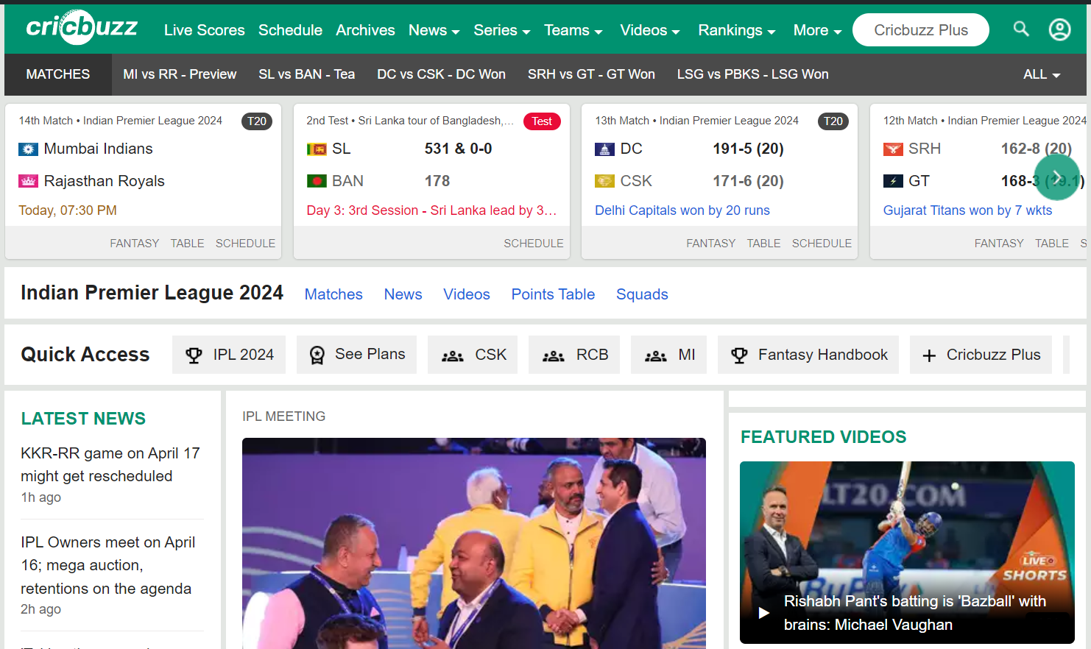

**CHAPTER 3**

**PROPOSED METHODOLOGY**

* 1. **: Background/Overview of Methodology**

Introduction to Agile Methodology:

Agile methodology is a flexible and iterative approach to project management that prioritizes collaboration, adaptability, and customer satisfaction. It emphasizes delivering incremental value to users through iterative development cycles and continuous feedback loops.

Overview of Agile Principles:

Agile methodology is guided by a set of principles outlined in the Agile Manifesto, which include valuing individuals and interactions over processes and tools, working software over comprehensive documentation, customer collaboration over contract negotiation, and responding to change over following a plan.

Relevance to the Project:

The Agile methodology was chosen for the SportConnect project due to its suitability for managing dynamic and evolving requirements in the university sports domain. By adopting Agile principles, the project team aims to prioritize user needs, respond to changing priorities, and deliver value incrementally throughout the development process.

Application in Development Process:

The SportConnect project will utilize Agile practices such as Scrum or Kanban to structure the development process into iterative cycles or sprints. Each sprint will focus on delivering specific features or functionalities based on user stories and feedback gathered from stakeholders. Regular sprint reviews and retrospectives will facilitate continuous improvement and adaptation.

Benefits of Agile Methodology:

The adoption of Agile methodology offers several benefits for the SportConnect project, including:

* Increased flexibility: Agile allows for changes to be made throughout the development process in response to evolving requirements or user feedback.
* Enhanced collaboration: Agile promotes collaboration between cross-functional teams, fostering a shared understanding of project goals and priorities.
* Faster time-to-market: By delivering working software incrementally, Agile enables earlier releases and quicker feedback loops, reducing time-to-market.
* Improved customer satisfaction: Agile prioritizes customer collaboration and feedback, ensuring that the final product meets user needs and expectations.

Challenges and Mitigations:

While Agile offers numerous advantages, it also presents challenges, such as managing scope creep, ensuring team alignment, and maintaining stakeholder engagement. To mitigate these challenges, the project team will employ strategies such as regular sprint reviews, clear communication channels, and prioritization of requirements based on business value.

Conclusion:

In conclusion, the Agile methodology provides a robust framework for the development of the SportConnect project, enabling the project team to deliver value to users iteratively, respond to changing requirements efficiently, and foster collaboration and innovation throughout the development process. By embracing Agile principles and practices, the SportConnect project aims to adapt to evolving user needs, deliver a high-quality product, and ultimately enhance the university sports experience for all stakeholders involved.

* 1. **: Project Platforms used in Project**

The SportConnect project leverages a range of tools and platforms to support development, collaboration, and communication. These platforms include:

Integrated Development Environments (IDEs):

* + - Visual Studio Code (VS Code) for writing and debugging code.
    - Xcode and Android Studio for platform-specific development tasks.

Version Control System:

* + - Git, hosted on platforms like GitHub or Bitbucket, for collaborative version control and code management.

Framework and Programming Language:

* + - Depending on project requirements, frameworks like React, Angular, or Vue.js may be utilized, along with languages like JavaScript or TypeScript.

Database Management and Authentication Services:

* + - MongoDB, PostgreSQL, or Firebase for data storage and management.
    - Authentication services such as Firebase Authentication or Auth0 for user authentication and authorization.

Build System and Tools:

* + - Webpack, Gulp, or Parcel for building and bundling project assets.
    - Continuous Integration (CI) tools like Jenkins or Travis CI for automated testing and deployment.

Collaboration and Communication Platforms:

* + - Slack, Microsoft Teams, or Discord for team communication and collaboration.
    - Project management tools like Jira, Trello, or Asana for task tracking and project planning.

By utilizing these platforms effectively, the SportConnect project benefits from streamlined development workflows, efficient collaboration, and effective communication among team members and stakeholders.

* 1. **: Proposed Methodology**

The proposed methodology for the SportConnect project outlines a systematic approach to developing a comprehensive and user-friendly platform for managing university sports events. The methodology

incorporates Agile principles and practices to ensure flexibility, adaptability, and continuous improvement throughout the project lifecycle. Key components of the proposed methodology include:

Agile Development Framework:

* + - Adoption of Agile methodologies such as Scrum or Kanban to structure development cycles into iterative sprints.
    - Emphasis on delivering incremental value to users through frequent releases and continuous feedback loops.

Cross-Functional Teams:

* + - Organization of cross-functional teams comprising developers, designers, testers, and domain experts to promote collaboration and shared accountability.
    - Regular communication and collaboration to ensure alignment with project goals and priorities.

User-Centric Design:

* + - Integration of user-centric design principles to understand user needs, preferences, and behaviors.
    - Continuous solicitation of user feedback and iteration based on user validation and testing.

Continuous Integration and Deployment (CI/CD):

* + - Implementation of CI/CD practices to automate build, test, and deployment processes.
    - Continuous integration of code changes and automated testing to ensure code quality and reliability.

Feedback Loops and Iterative Improvement:

* + - Establishment of feedback loops with stakeholders, users, and team members to gather insights and identify areas for improvement.
    - Regular retrospectives and sprint reviews to reflect on progress, identify lessons learned, and plan for iterative improvements.

Lean Startup Methodology:

* + - Application of Lean Startup principles to validate assumptions, test hypotheses, and iterate on product features rapidly.
    - Development of Minimum Viable Product (MVP) iterations to gather early user feedback and validate key assumptions.

By following this proposed methodology, the SportConnect project aims to deliver a robust, user-centric platform that meets the evolving needs of university sports communities while fostering collaboration, innovation, and continuous improvement throughout the development process.

* 1. **: Project Modules**

The SportConnect project comprises several modules designed to facilitate various aspects of university sports event management and participation. These modules include:

Event Management:

* + - This module allows administrators to create, manage, and promote university sports events, including scheduling, venue management, and participant registration.

User Registration and Authentication:

* + - Users can create accounts, log in securely, and manage their profiles, preferences, and notifications within the platform.

Event Registration and Participation:

* + - Users can browse upcoming sports events, register to participate, and receive event notifications and updates.

Communication and Collaboration:

* + - This module facilitates real-time communication and collaboration among event participants
  1. **: Diagrams**

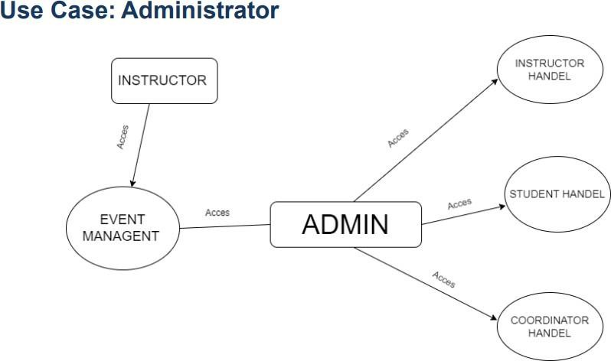

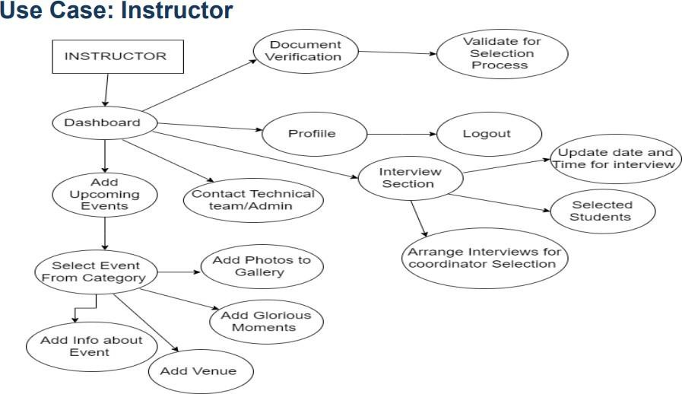

**Use Case: Coordinator**

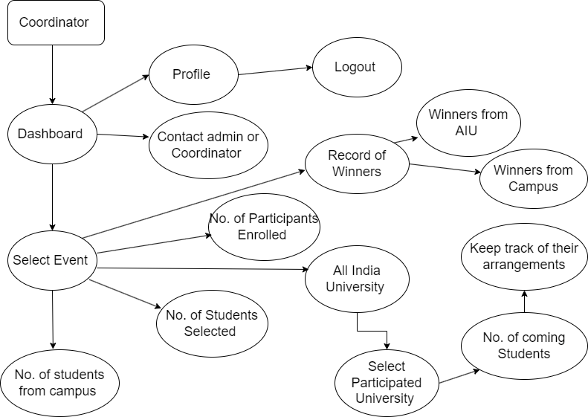

**Use Case: Student**

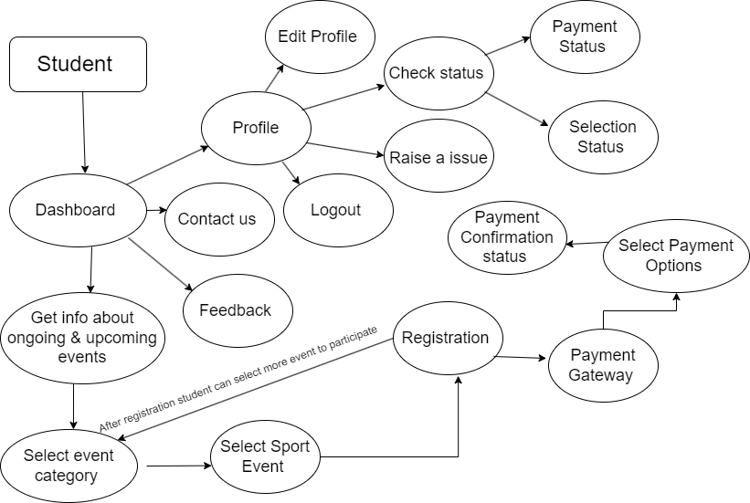

**CHAPTER 4 SYSTEM REQUIREMENTS**

* 1. **: Software Requirements**

The "SportConnect" project has defined specific software requirements to support the development, testing, and deployment of the application. These requirements ensure that the development environment is properly configured and compatible with the tools and technologies used in the project. The software requirements include:

1. Integrated Development Environments (IDEs):

* Visual Studio Code (VS Code) and Android Studio are the recommended IDEs for developing the "Sport Connect" application.
* These IDEs provide features such as code editing, debugging, version control integration, and support for programming languages

1. Version Control System (VCS):

* Git is used as the version control system for managing source code changes and collaboration among team members.
* GitHub serves as the hosting platform for Git repositories, facilitating code sharing, code review, and issue tracking.

1. Frontend Frameworks and Libraries:

* React.js: A JavaScript library for building user interfaces, React.js can be used for developing the frontend of the SportConnect website.
* Vue.js or Angular.js are alternative frameworks that can also be utilized based on project requirements.
* These frameworks provide components, state management, and routing functionalities for building interactive web applications.

1. Build Tools:

* Webpack or Parcel: Build tools like Webpack or Parcel can be used to bundle JavaScript files, CSS, and other assets for deployment.
* Babel: Babel can be used for transpiling modern JavaScript code into backwards-compatible versions to ensure compatibility with older browsers.

1. Backend Services (Optional):

* Node.js: Node.js is used as a runtime environment for executing JavaScript code on the server.
* Express.js: A lightweight framework for building web applications with Node.js, Express.js can be used for creating RESTful APIs and handling server-side logic.
* MongoDB or MySQL: Databases such as MongoDB or MySQL can be used for storing data related to sports events, user profiles, and other relevant information.

1. Communication Platforms:

* Collaboration and communication platforms such as Discord, and Google Meet are used for team communication, coordination, and meetings.
* These platforms facilitate real-time communication, file sharing, and collaboration among team members working on different aspects of the project.
  1. **: Hardware Requirements**

The "SportConnect" website requires specific hardware specifications to support its development, testing, and deployment phases, ensuring optimal performance and compatibility across different devices and platforms. The hardware requirements are as follows:

1. Development Machines:
   * Development machines serve as the primary workstations for developers, designers, and other team members involved in the project.
   * Minimum specifications for development machines typically include:
     + Processor: Intel Core i5 or AMD Ryzen 5 processor (or equivalent)
     + RAM: 8GB of RAM or higher
     + Storage: Solid-state drive (SSD) with at least 256GB of storage capacity
     + Operating System: Windows 10, macOS, or Linux-based operating system
2. Mobile Devices:
   * Mobile devices are essential for testing and debugging the "SportConnect" application on real-world devices, ensuring compatibility and performance across different platforms.
   * Recommended mobile devices for testing include:
     + Android Devices: Google Pixel, Samsung Galaxy series,Motorola devices etc.
     + iOS Devices: iPhone models (e.g., iPhone SE, iPhone 15) running the latest iOS version
3. Server Infrastructure:
   * Server infrastructure is required to host the backend services, databases, and application logic necessary for the operation of the "SportConnect" application.
   * Recommended server specifications for hosting services such as Supabase or other cloud platforms include:
     + Processor: Dual-core or quad-core processor with sufficient processing power
     + RAM: 8GB of RAM or higher for optimal performance
     + Storage: Solid-state drive (SSD) with ample storage capacity for database storage and file storage needs
4. Network Infrastructure:
   * Reliable network infrastructure is essential for ensuring seamless communication between client devices and backend services.
   * Stable internet connectivity with sufficient bandwidth is required for development, testing, and deployment activities.
   * Local area network (LAN) or Wi-Fi connectivity is recommended for team collaboration and communication during development sprints and meetings.

By adhering to these hardware requirements ensures that team members have access to the necessary resources and infrastructure to develop, test, and deploy the "SportConnect" website effectively. Additionally, testing on real mobile devices and reliable network connectivity contribute to delivering a high-quality and user-friendly website experience for users.

**CHAPTER 5 EXPECTED OUTCOMES**

* 1. **: Introduction**

The expected output of the website SportConnect embodies the culmination of our efforts to revolutionize the university sports experience. Through meticulous planning, innovative design, and advanced technology integration, SportConnect aspires to deliver a dynamic and user-centric platform that redefines how students, administrators, instructors, and coordinators engage with sports events within our university community.

At its core, the expected output of SportConnect is a comprehensive online ecosystem that facilitates seamless communication, efficient coordination, and active participation in a diverse array of sports activities. It serves as a centralized hub where users can access vital information, register for events, collaborate with peers, and contribute to the vibrant sports culture thriving within our university.

The expected output of SportConnect encompasses several key features and functionalities aimed at enhancing the overall sports experience:

**User-Friendly Interface:** The website will boast an intuitive and easy-to-navigate interface, ensuring that users can effortlessly access relevant information, register for events, and engage with the platform's various features.

**Centralized Information Hub:** SportConnect will serve as a centralized repository for all information related to university sports events, including schedules, rules, venues, and participant lists, providing users with a comprehensive overview of upcoming activities.

**Event Management Tools:** Robust event management tools will empower administrators and coordinators to efficiently organize and coordinate sports events, from scheduling and venue arrangements to participant communication and registration management.

**Talent Identification and Team Formation:** Instructors will have access to tools and functionalities for talent scouting, performance evaluation, and team formation, enabling them to assemble competitive teams across different sports disciplines.

**Community Engagement Features:** SportConnect will foster community engagement through interactive features such as discussion forums, social media integration, and virtual communities, facilitating interactions, collaborations, and networking among users.

**Mobile Accessibility:** The website will be optimized for mobile devices, ensuring that users can access SportConnect anytime, anywhere, enhancing accessibility and convenience for all stakeholders.

* 1. **: Features**

**1. Login and Sign Up**

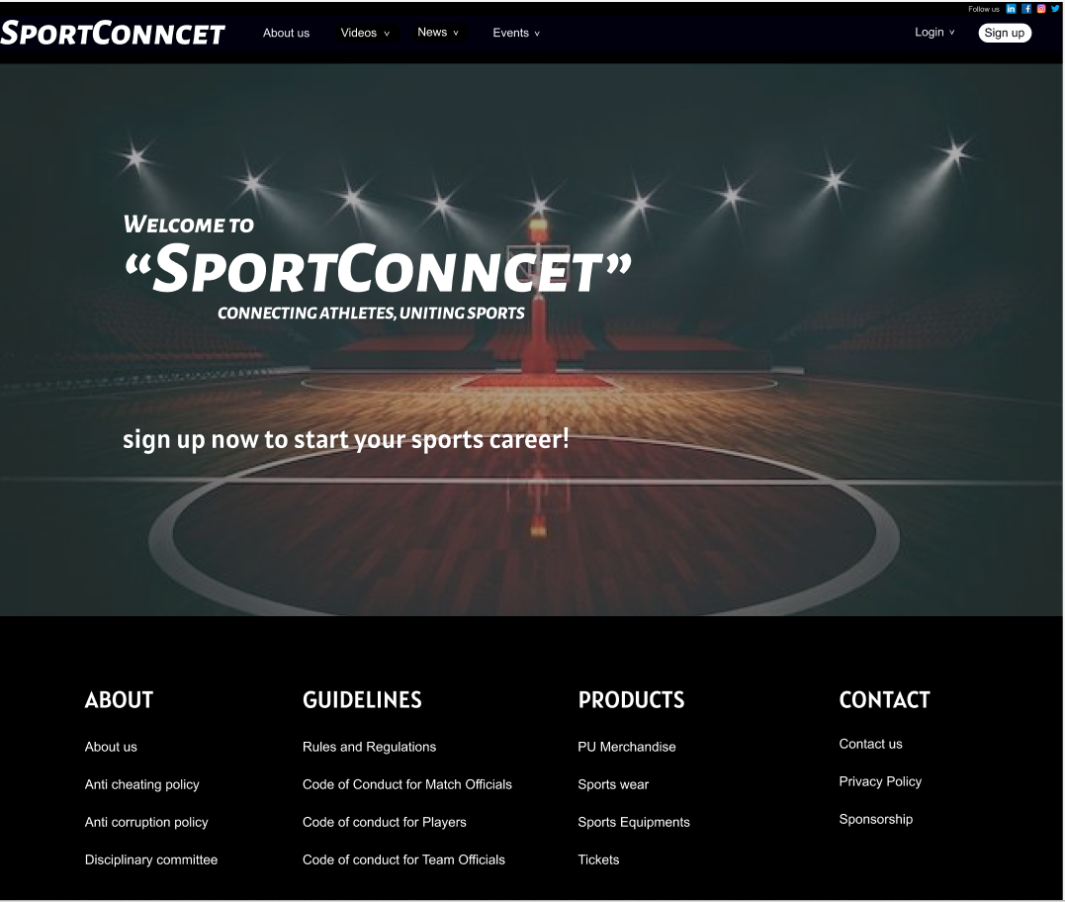

**Basic Home page**

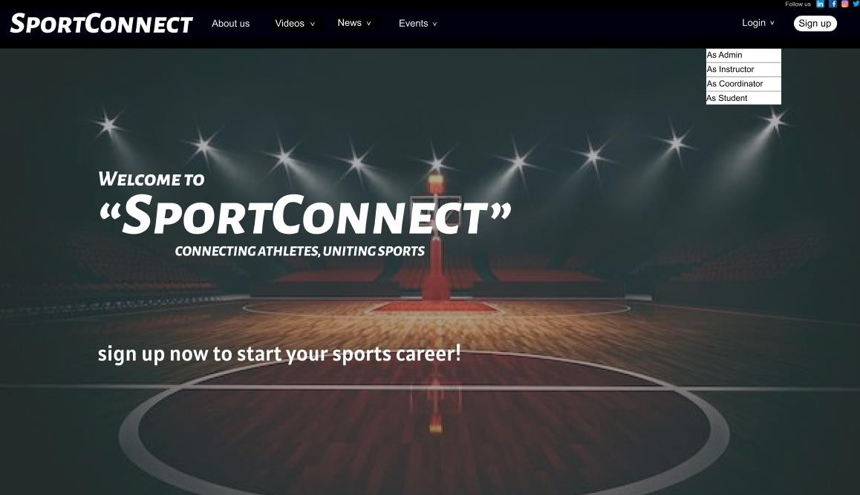

**There are 4 kind of users when you Login or Signup .**

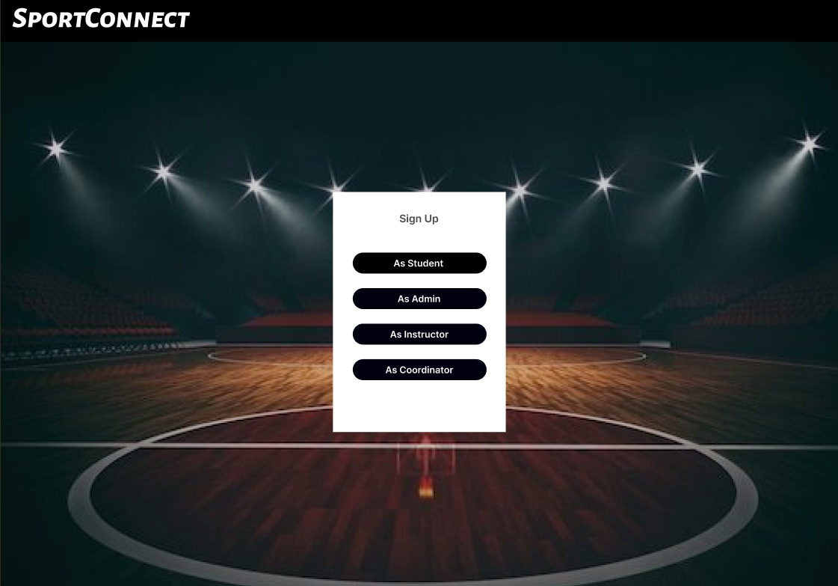

**After selection of your user type , you have to login or signup with your email.**

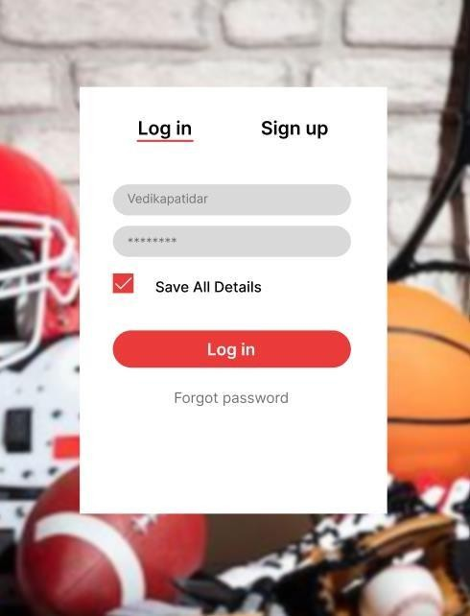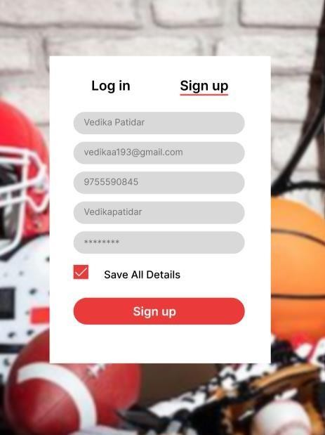

**After Signup you have to verify your email.**

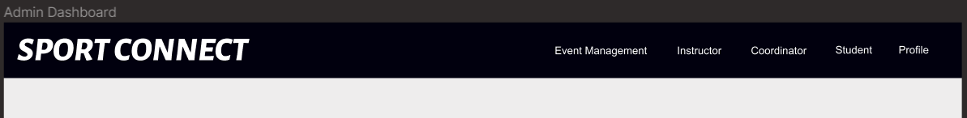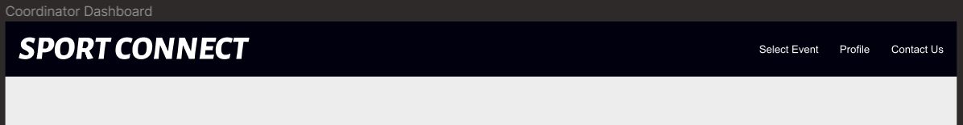

**All above figures are the Dashboards of 4 Users.**

**STUDENT DASHBOARD**

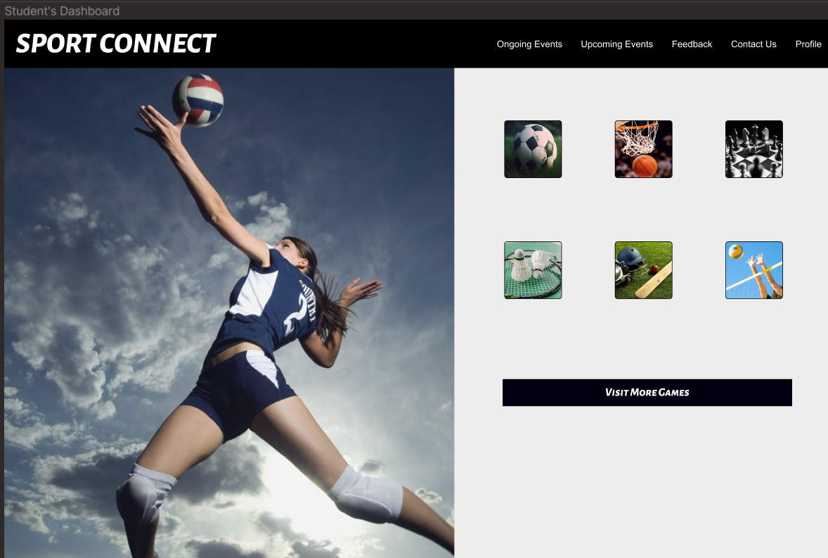

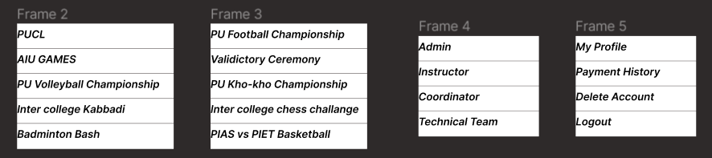

The Above details show when you click on the ongoing events , Upcoming events , Contact us, profile.

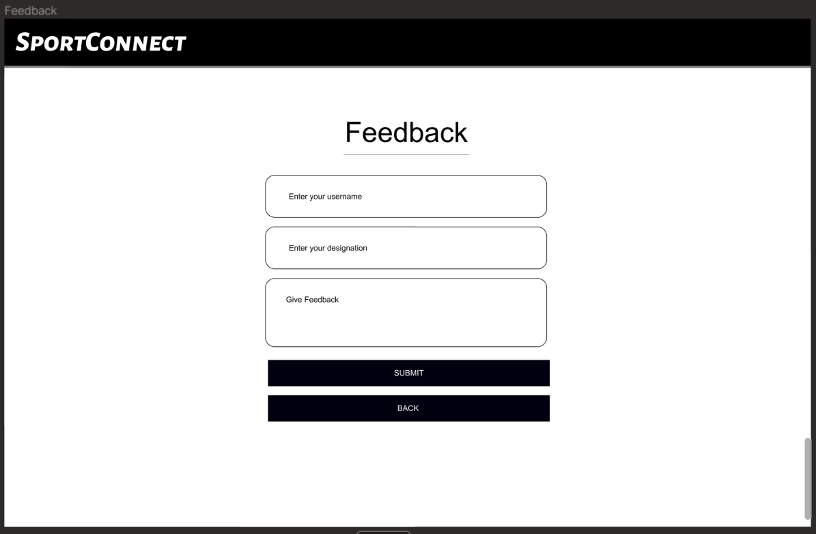

**ADMIN DASHBOARD**

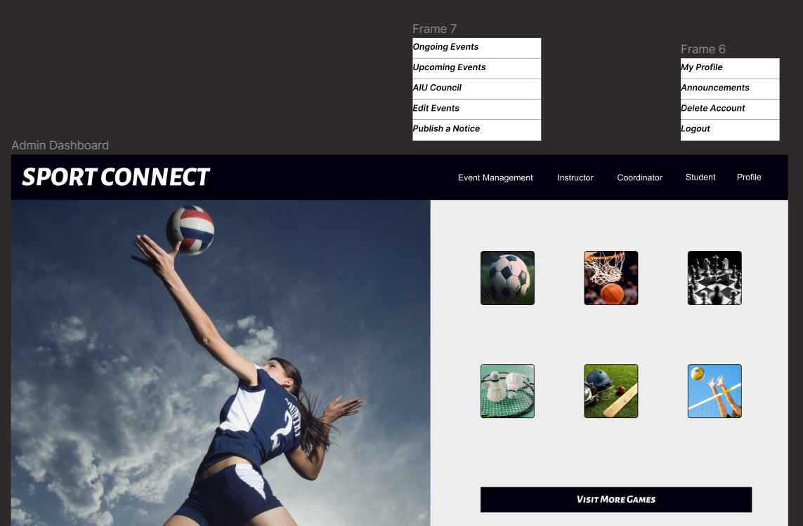

Above image is the dashboard of admin , in which when you click on event management and profile it shows you some options and when you click on instructor , Coordinator , Student it will open there login pages.

**INSTRUCTOR DASHBOARD**

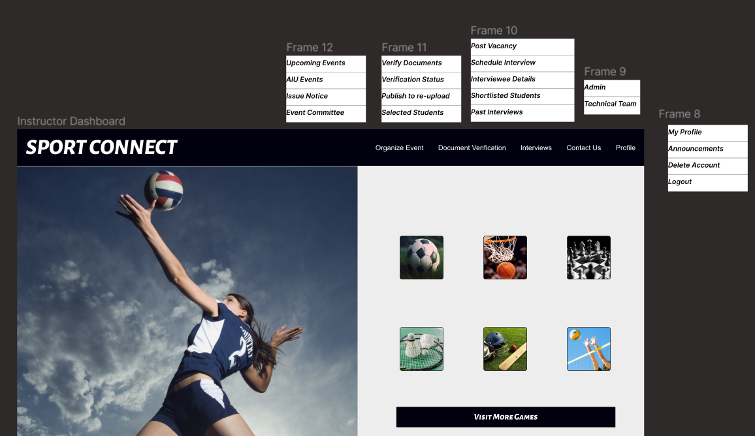

**COORDINATOR DASHBOARD**

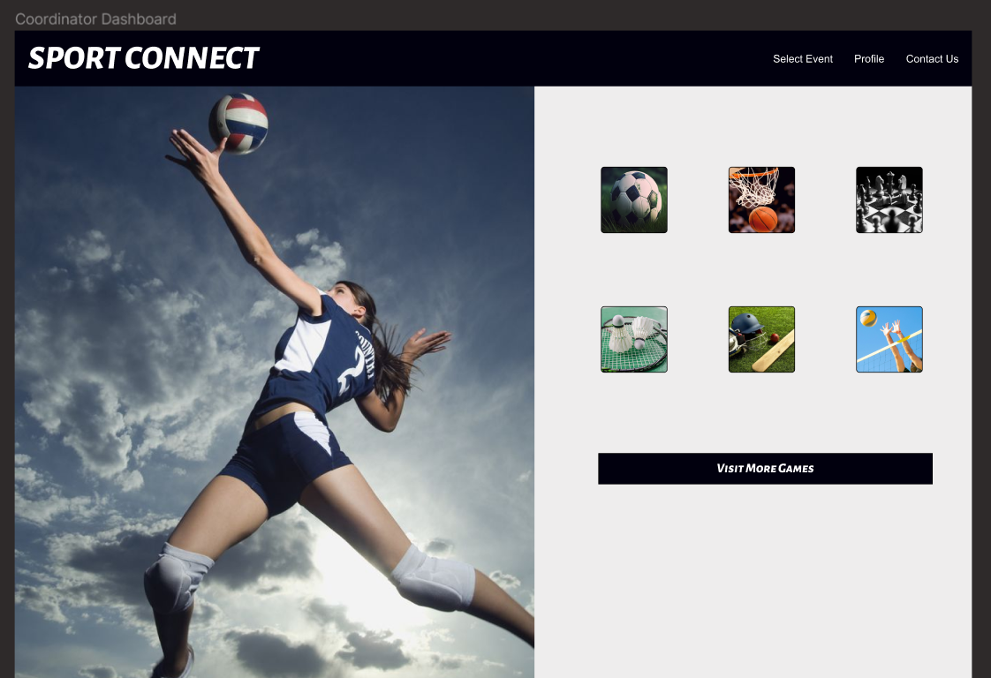

**CHAPTER 6 CONCLUSION AND FUTURE WORK**

* 1. **: Conclusion**

The development journey of the SportConnect project has been an exhilarating adventure, resulting in the creation of a dynamic and inclusive platform for university sports enthusiasts. From inception to implementation, our team has dedicated efforts to conceptualize, design, and deploy a solution that caters to the diverse needs of students, administrators, instructors, and coordinators within our university community. As we conclude this project, several key takeaways emerge:

1. Achievement of Objectives:

SportConnect has successfully met its objectives of providing a centralized platform for organizing, managing, and participating in university sports events. Users can seamlessly access event information, register for activities, and engage with fellow sports enthusiasts, fostering a sense of community and camaraderie.

1. Scope Adherence:

Throughout the project lifecycle, we have remained committed to adhering to the defined scope and requirements, ensuring that essential features and functionalities are implemented to enhance user experience and facilitate efficient event management.

1. Agile Methodologies:

The adoption of Agile development methodologies has been instrumental in facilitating collaboration, adaptability, and continuous improvement throughout the project. Agile principles have enabled us to respond effectively to changing requirements, iterate on designs, and deliver value incrementally to our users.

1. Technological Advancements:

Leveraging cutting-edge technologies and modern development frameworks, SportConnect has been crafted to meet industry standards and user expectations. The integration of mobile optimization, data analytics, and social media features enhances the platform's functionality and accessibility.

1. User-Centric Approach:

A user-centric design philosophy has guided our development process, ensuring that user feedback and preferences remain at the forefront of decision-making. Through usability testing, feedback sessions, and iterative design iterations, we have strived to create an intuitive and engaging sports experience for all users.

1. Future Prospects:

While the SportConnect project marks a significant milestone, there are abundant opportunities for future enhancements and expansions. Potential avenues for future work include integrating additional features, enhancing performance, and exploring possibilities for scalability and integration with other educational institutions.

In conclusion, SportConnect stands as a testament to the dedication, collaboration, and innovation of our project team. We are immensely proud of the accomplishments achieved thus far and remain committed to furthering the platform's impact on university sports engagement and community building. As we embark on the next phase of development, we are excited about the possibilities that lie ahead and remain steadfast in our commitment to delivering value and excellence to our users within the university sports ecosystem.

* 1. **: Future Scope**

As we look ahead beyond the initial phase of the SportConnect project, there are numerous opportunities for future development and expansion. The following outlines potential areas for future scope and enhancements:

1. Enhanced User Experience:

Continuously improving the user experience will remain a key focus. Future iterations could involve refining the user interface, simplifying navigation, and optimizing performance to ensure a seamless and enjoyable experience for all users.

1. Additional Features and Functionalities:

Introducing new features and functionalities can further enrich the platform. This may include personalized event recommendations, interactive training modules, gamification elements to encourage participation, and integration with wearable fitness devices.

1. Mobile App Optimization:

Optimizing the SportConnect mobile application for different devices and operating systems can broaden its accessibility and reach. Enhancements in responsiveness, offline functionality, and push notifications can enhance the user experience on mobile devices.

1. Community Engagement and Interaction:

Strengthening community engagement is crucial for fostering a sense of belonging among sports enthusiasts. Future efforts may focus on enhancing community features such as discussion forums, user-generated content sharing, live streaming of events, and virtual training sessions.

1. Monetization Strategies:

Exploring sustainable monetization strategies can support the growth and sustainability of the platform. This may involve offering premium subscription plans for advanced features, partnering with sports brands for sponsorship opportunities, and incorporating targeted advertising.

1. Geographic Expansion:

Expanding the reach of SportConnect to other universities or regions can unlock new markets and user bases. Localized versions of the platform, support for multiple languages, and partnerships with regional sports organizations can facilitate global expansion.

1. Integration with External Services:

Integrating with external services and platforms can enhance the functionality and value proposition of SportConnect. This may include integration with fitness tracking apps, sports equipment retailers, ticketing platforms for sports events, and social media for seamless sharing.

1. Data Analytics and Insights:

Leveraging data analytics and insights can provide valuable intelligence for decision-making and optimization. Implementing analytics tools to track user engagement, event participation, and performance metrics can inform future enhancements and strategic initiatives.

1. Security and Privacy Enhancements:

Strengthening security measures and privacy protections is essential for safeguarding user data and maintaining trust. Implementing robust authentication methods, encryption protocols, and compliance with data protection regulations will be paramount.

1. Continuous Improvement and Innovation:

Embracing a culture of continuous improvement and innovation will be critical for staying competitive and relevant in the dynamic sports industry. Regular feedback collection, technology updates, and experimentation with new features will drive ongoing innovation and evolution of SportConnect.

In summary, the future scope of the SportConnect project is vast and promising. By focusing on user engagement, technological innovation, community building, and strategic partnerships, the platform can evolve into a leading destination for university sports enthusiasts, fostering a vibrant and inclusive sports community within and beyond our university.

**CHAPTER 7 REFERENCES**

* 1. <https://www.w3schools.com/html/html_css.asp>
  2. <https://www.lucidchart.com/pages/how-to-draw-ERD>
  3. <https://www.atlassian.com/agile>
  4. <https://budibase.com/blog/how-to-make-a-web-app/>
  5. <https://chat.openai.com/>
  6. <https://www.codeproject.com/>